**ONLINE APPOINTMENT SCHEDULING   
Administrator Instructions**

**Online Scheduling** www.ucdir.com

**Church Code –**

**Admin password church**

**Member password - photos**

**These are case sensitive!**

**TO ACCESS THE ONLINE SCHEDULE**

* Go to the Universal Church Directories website **(www.ucdir.com)**
* Click on the box to the right that says **“photography appointment scheduling login”**
* Enter your church code  **Note: Church Code & Password are case sensitive**
* 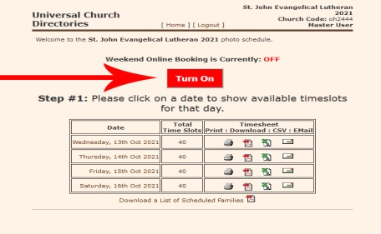Enter Administrator’s password **church**
* Click on the Enter button

**TO KEEP THE ONLINE SCHEDULE ON OVER THE WEEKEND**

* From the admin homepage, click the turn on button.
* To Turn the weekend sign ups, click the off button

**TO SCHEDULE A FAMILY’S PHOTOGRAPHY APPOINTMENT**

* Table

  Description automatically generatedClick on the desired day/date
* Locate the desired time and click on the “Edit Entry” icon
* Enter the # in Family, First Name, Last Name, Phone # & Email
* Click on the “Schedule Appointment” button to finalize

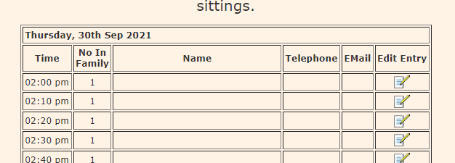

**TO EDIT OR CANCEL A FAMILY’S PHOTOGRAPHY APPOINTMENT**

* Click on the day/date of the family’s photography appointment
* Locate the family’s entry on the scheduling screen
* Click on the same “Edit Entry” icon used to schedule an appointment (as shown above)
* **To Edit** family information: Change the appropriate information, then click on the “Schedule Appointment” button at the bottom of the screen
* **To Cancel** a family photography appointment: Just click on the “Clear Appointment” button at the bottom of the screen
* **To Change** an Appointment Time: The original appointment must be cancelled & re-entered

# TO PRINT PHOTO SCHEDULES for Weekend Sign-Ups at Church

* Click on the **PDF** icon beside the date of photography

to print that day’s schedule for weekend sign-ups at church

# TO PRINT SCHEDULES to Give to The Photographer on Picture Day

* 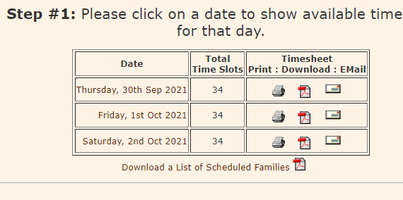Click on the **PRINTER** icon beside the date of photography to   
  print that day’s schedule. This is a smaller, one-page version   
  of the day for the photographer

**Email Reminders - Important!   
Send Reminder Email 2 Days Before Each Photo Day!**

* This is how to send an email to each family with an email listed for an entire day at once! (Each day is sent separately)
* Click on the **EMAIL** icon (it looks like an envelope) in the box for the day of photography
* Enter an optional brief message in the Message field in the form that pops up… ie: photo location, Pastor note, etc)
* Click on the Send Email button
* Reminder calls should be made too….**especially** to those without emails listed

